COLLEGE LOGO: 

INSITTUTE NAME: - Delhi College Astha

ADDRESS: - GRAM RICHADIYA, DEWAN KHEDI ROAD, BEHIND MAA DAYALU WARE HOUSE, KANNOD ROAD, ASHTA, DISTRICT: - SEHORE (M.P), PIN NO. : 466116

SOCIETY NAME: COMIENZO EDUCATIONAL SAMAJIK LOK KALYAN SAMITI, INDORE

CONTACT PERSON NAME: ISHWAR NAYAK

PHONE NO. : 8370000133, 9584112000

Email id : delhicollegeashta@gmail.com

PROGRAMME:

POST GRADUATE DIPLOMA IN MANAGEMENT (PGDM)

TWO - YEAR (FULL-TIME)

Delhi College has evolved as an institution of excellence and commitment in the field of Management and Technical education. The institute from the very outset focused on professional studies at the Post- Graduate level with a view to tap, direct and channelize the enormous talent pool in the country. We offer Post Graduate Diploma in Management (PGDM) (two year - Full Time).

PGDM PROGRAMME

PGDM Programme is renowned for its extensive and in depth coverage of core and specialized courses, creating innovation and entrepreneurial qualities. The Programme is approved by the All India Council for Technical Education (AICTE), Ministry of HRD, and Government of India. PGDM has also been granted equivalence to MBA degree by Association of Indian Universities (AIU).

In our PGDM programme, we offer following specializations, spanning over two years; It is designed to provide students with first-hand experience of corporate culture.

* Marketing
* Finance
* Human Resource
* Operations
* International Business (minor only)

Students pursuing management course can opt for a dual specialization in any of the above streams, subject to conditions.

The program is spread across six trimesters and a summer internship. While the first three trimesters focus on building a strong foundation in the management discipline, the remaining three trimesters enable the students to specialize in the area of their interest.

SUMMER INTERNSHIP

Internship programs are one of the best ways to bring the academic and business community together. It is a win-win situation for both the students of the institute as well as the company providing internship.

Student benefits include:

* Chance to apply theoretical learning into practice
* Gaining corporate experience
* Building network

Employer benefits include:

* Accessing ready talent pool
* Spotting future employees
* Decreasing recruitment cost significantly

PEDAGOGY

At JIMS, we believe that there is no single and universal approach that suits all situations. Therefore, our faculty members use an array of teaching methodologies using different combinations with different group of students, thereby improving the learning experience. The whole gamut of teaching and learning methods include - case studies, role plays presentation on strategic and contemporary issues, simulation exercises, industrial visits, workshops and seminars.

#### PROJECT REPORTS

The project reports usually serve as an excellent channel for students to have close interaction with industryexperts and therefore provide ample opportunity to the students to demonstrate their analytical and problem solving skills.

On preparation of project reports, there is a formal presentation session wherein we invite the corporate executives and faculty members to assess student’s work and share their valuable feedback.

## THE SOCIETY

#### COMIENZO EDUCATIONAL SAMAJIK LOK KALYAN SAMITI

COMIENZO EDUCATIONAL SAMAJIK LOK KALYAN SAMITI is a Registered Society under the mp Societies Registration Act and is a non profit organization. The Society is managed by learned people drawn from academics, industry and business. The Chairman of the Society, Mr. Sunil Shivhare is an MBA in HR from IMS, Indore. The Society is keenly devoted to the cause of professional education.

## THE INSTITUTE

Delhi College is imparts professional education at post graduate levels in the fields of Management. The Institute has been working for the attainment of a mission: to develop highly skilled and professional human resource for industry and business.. Our PGDM Programme is to be approved by the All India Council for Technical Education for excellence in quality education. PGDM has also been granted equivalence to MBA degree by Association of Indian Universities (AIU).

DC is a place of learning for knowledge-driven learners. It has been built with an aim to impart education that surpasses the benchmarks of excellence. To achieve the motto it has a comprehensive pedagogical structure which provides paramount academic skills, curriculum with the ever-evolving dynamics of global business environment, esteemed faculty members with their vast experience and expertise and world class facilities.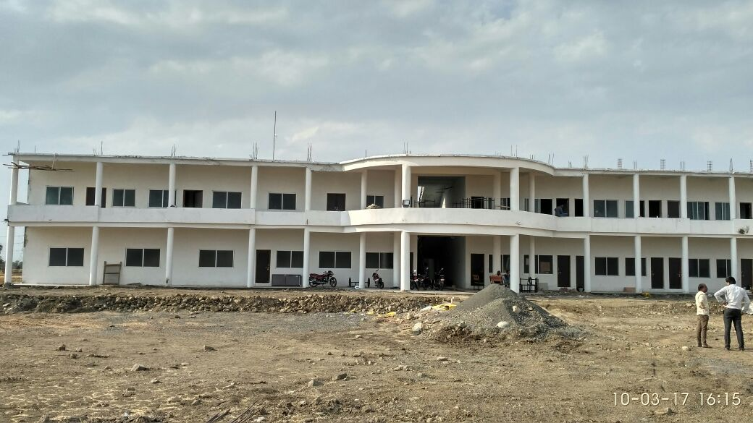

Vision

To be a excellence in management education, widely known for the development of competent and socially responsible business leaders, entrepreneurs and researchers.

Mission

* To impart established and contemporary management knowledge
* To synchronize concepts, logic and skills for effective business decision making
* To encourage entrepreneurial environment and nurture innovative ideas
* To foster research and provide consultancy service to the corporate
* To promote awareness towards social issues through various group activities and events.

Programme Educational Objectives

* To develop technical competence in various functional domains such as Marketing, Finance, HR, Operations, International Business, and Retail
* To ensure Employability and exponential career growth of students.
* To sharpen decision making skills to ensure sustainability in competitive business environment
* To develop socially responsible corporate citizens.
* To impart entrepreneurial skills to establish and run successful business ventures.
* To imbibe confidence and improve personality of the students through regular individual and group activities, Presentations, Role plays and Personality development & Communication sessions
* Improve the campus environment by building effective relationship among faculty, student and alumni.
* To impart and disseminate knowledge through innovative pedagogy to develop the future business leaders.

Programme Outcomes

* Expected to understand theoretical framework of management fundamentals
* Expected to apply programme learning to practical business situations
* Expected to demonstrate appropriate behavioral dimensions at work place
* Ability to identify, analyze, present business issues and make quantitative and qualitative decisions in the respective specialization
* Ability to use relevant IT tools